A 360° view of additive manufacturing: The VDWF invites you to its third practical forum

“The potential is immense”, says Prof. Stefan Roth, Department of Applied Plastics Technology at Schmalkalden University. Roth leads the VDWF’s “Additive Manufacturing” working group together with Prof. Julian Polte of the Fraunhofer Institute for Production Systems and Design Technology IPK Berlin, and whose involvement in the program’s creation played a key role. “Unfortunately, many companies – especially those in tool and mold making – have yet to fully take advantage of it. Often, this is because they have yet to be familiar with the possibilities of current technologies, and therefore cannot determine all the areas where additive manufacturing may be worthwhile.” The VDWF practical forum addresses this problem. This year’s motto is: “A 360° perspective of additive manufacturing: Efficient solutions for tool- and prototype construction from the perspective of technology, research, service, and application”.

This year’s “Additive Manufacturing” practical forum will take place on June 27th and 28th. GF Machining Solutions in Schorndorf will be hosting. At least five specialist lectures have been planned for each of the two days. In addition, there will be a technology tour at GF with a focus on 3D printing and (of course) a large evening event participants can use for networking.

Current Trends in Research and Practice

Expanding the perspectives from which one looks at this topic means focusing on current research. Research representatives will present the latest developments, such as arc-based additively manufactured tools and granule processing for fiber-reinforced materials. In addition, company experts will present concrete practical applications such as 3D hybrid processes and fiber-reinforced metal components. You will hear from different industries and companies - from medium-sized companies to large OEMs in the automotive sector. The perspective of suppliers and service providers is also shown in addition to tool and mold making companies. These include solutions familiar to a machine manufacturer and a full-service 3D printing provider, and how AM printing jobs can be calculated correctly.

Roth explains: “We hope that through these many examples, we can provide concrete insights into what is now possible.” Because: “The technology is already there. Now it’s just a matter of using it.”

“VDWF Toolmaking Meet-Up” Evening Event

The VDWF eroder-meeting will take place concurrently with the “Additive Manufacturing” practical forum on June 27th at GF Machining Solutions. Also scheduled on the same day is the “Toolmaking Meet-Up”. This after-work event for the industry will include a keynote speech by legendary referee Lutz on the topic of “Decision making in stressful situations”. Participants in the Additive Manufacturing Practice Forum and the EDM meeting will get to meet, round off the evening together, and exchange ideas. Culinary support for networking will of course be provided.

Registration for the “Additive Manufacturing” practical forum is open at www.vdwf.de/termine. The VDWF looks forward to many participants.

Presentations

- “Additive Manufacturing in the Automotive Sector – Current News from Prototyping and Tool Production”, Martin Bock, Audi
- “Advanced 3D Printing – Smart Fusion, Beam-Shaping, and New Materials”, Georg Lochner, EOS
- “Energy- and Resource Efficiency through Arc-Based Additively Manufactured Tools Using the DED-Arc Process”, Johannes Ullrich, Schmalkalden University
- “Economical Additive Manufacturing in Tool and Mold Making Using 3D Hybrid Processes”, Ole Jenzevski, Matsuura Europe
- “Building Sustainable Process Chains Using Additive Manufacturing”, Julian Polte, Fraunhofer Institute for Production Systems and Design Technology IPK
- “State-of-the-Art Solutions for Rapid Tooling from the Perspective of a Full-Service 3D Printing Service Provider”, Johannes Bernhardt, FKM Sintertechnik
- “Trends and Further Developments in Additive Manufacturing for Industrial Use through Granulate Processing: Large-Format Systems and Processing of Fiber-Reinforced Materials”, Oliver Keßling, Baden-Württemberg Cooperative State University Stuttgart
- “Filament-Based Additive Manufacturing of Metallic Components”, Uwe Lohse, Xerion Berlin Laboratories
- “The Hourly Rate Dilemma – Correct Calculation of AM Printing Jobs”, Claus Hornig, Claho

Captions

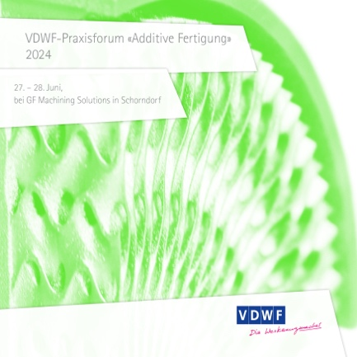
vdwf_praxisforum_additive_produktion_2024.jpg
The VDWF practical forum “Additive Manufacturing” will take place on June 27th and 28th at GF Machining Solutions in Schorndorf.
(Image: VDWF)

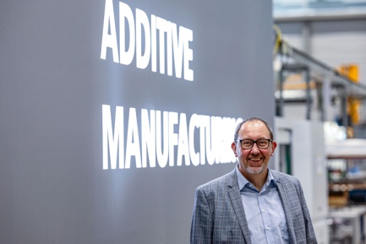
M42_6418.jpg
Prof. Stefan Roth and Prof. Julian Polte will jointly lead the VDWF “Additive Manufacturing” working group.
(Image: VDWF)

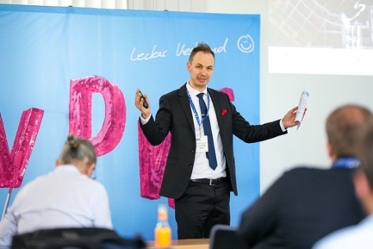
M42_6418.jpg
Prof. Julian Polte and Prof. Stefan Roth jointly head the VDWF “Additive Manufacturing” working group.
(Image: VDWF)

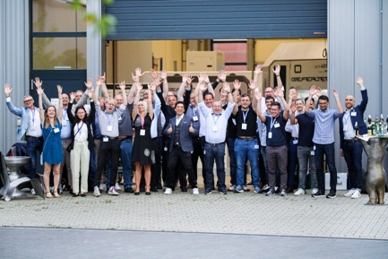
M42_1407.jpg
Participants of last year's VDWF practical forum “Additive Manufacturing” are visiting the Gefertec workshop.
(Image: VDWF)

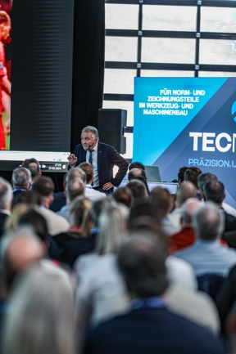
M41_0841.jpg
Legendary Referee Lutz Wagner will once again entertain and inform participants at the evening’s “Toolmaking Meet-Up” with his keynote speech on “Decision Making in Stressful Situations”.
(Image: VDWF)

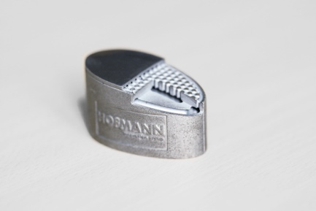
M42_0912.jpg
3D printing in tool and mold making: sample application of a contour-tempered tool insert
(Image: VDWF)

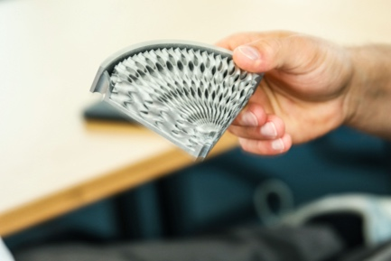
M42_1824.jpg
Sample of an additively manufactured high-performance cooling system for tool and mold making
(Image: VDWF)
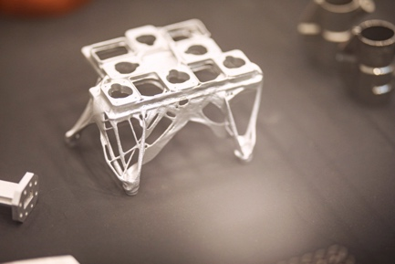
M42_6381.jpg
Some possibilities of 3D-printed lightweight structures
(Image: VDWF)

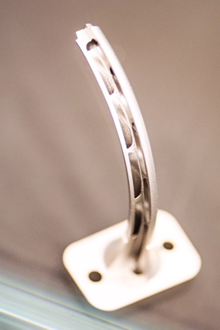
M42_6448.jpg
3D-printing in tool and mold making: sample application of a contour-tempered tool insert
(Image: VDWF)

High-resolution images can be found in the Press section of the VDWF website (www.vdwf.de/service/presse-vdwf).

