Over 70 co-exhibitors at the VDWF joint stand: A new round of Moulding Expo after a four-year hiatus

The largest tool and mold making event in Europe is imminent: After a four-year hiatus due to the pandemic, the Moulding Expo will once again take place in Stuttgart from June 13th to 16th. This fair is an exhibition of tool-, model-, and mold making, and is held in the middle of the largest market for industrial goods, and in Europe’s most beautiful and modern exhibition center.

The VDWF set a record at the 2019 Moulding Expo: its joint stand of around 80 participants on over 1000 m2 was the largest in the association’s 30-year history. The association will build on this success in 2023: over 70 companies have registered to take part, so the stand in the middle of Hall 1 will again be a crowd magnet.

The international trade fair’s focus is on tool-, model-, and mold making - but system suppliers and service providers for everything plastics technology and metalworking are exhibiting: from material suppliers to hot runner manufacturers, suppliers of measuring and test equipment to software houses. A supporting program of workshops, lectures, and discussion rounds will offer insights into relevant topics such as sales, purchasing, contract law, and technical knowledge about automation, digitization, and sustainability. As part of a special show, Innonet will doing a live presentation of the individual steps involved in the production of delicate plastic tweezers - from tool construction and plastic processing to joining and printing. In addition, the Medal of Honor for special service to the industry will be awarded at the Moulding Expo Exhibitor’s Evening on June 15th. The fourth winner of this award will be chosen by an independent jury consisting of VDWF, VDMA, VDW, and WBA association representatives.

"The VDWF is the trade fair’s conceptual and technological trustee - it is our flagship, so to speak," explains VDWF Managing Director Ralf Dürrwächter. "That's why it is a very special highlight that we're all eagerly awaiting." He adds that after the long break, anticipation among exhibitors and visitors is particularly high when the entire industry finally comes together again in one place. So, in addition to visiting the VDWF joint stand, Dürrwächter also cordially invites all industry players to the association's stand party on Wednesday evening of the trade fair. "Networking with good food and cold drinks - what could be better?" Anyone interested can book a free ticket on the Moulding Expo website with the registration code "MEX23VDWF".

captions

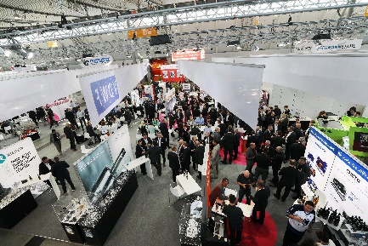
M44_4190.jpg
(Photo: VDWF)
Superlative Moulding Expo: In 2019, the VDWF presented its largest exhibition stand to date with around 80 co-exhibitors on over 1000 m².

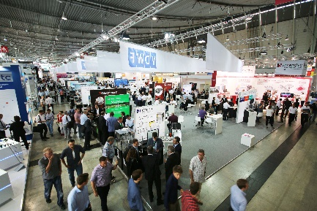
IMG_2912.jpg
(Photo: VDWF)
Moulding Expo 2017

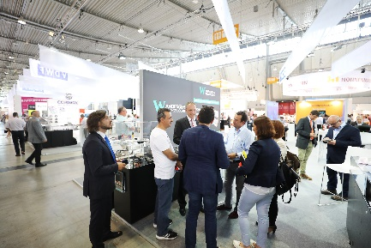
IMG_5461.jpg
(Photo: VDWF)
Moulding Expo 2017

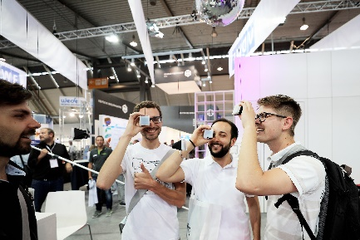
IMG_3407.jpg
(Photo: VDWF)
Moulding Expo 2017

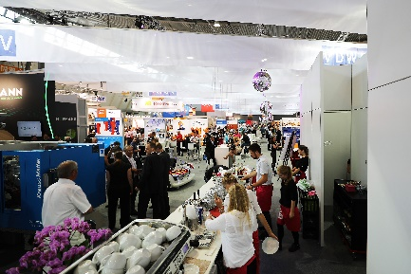
IMG_5385.jpg
(Photo: VDWF)
Moulding Expo 2017

