Ringing in the New Year 2024 With Over 500 VDWF Members!

Exchanges between companies have become indispensable – especially in the past few turbulent years. The tool and mold making industry is connected nationwide through the VDWF – and this network is becoming ever more closely-knit.

The “2023 Year-End Rally”, as VDWF Managing Director Ralf Dürrwächter put it, was characterized by sold-out events and intensive discussions. December is a time to both step on the gas and to reflect on the past and strive for innovations. The VDWF was pleased to welcome 15 new member companies in the last month of 2023 alone. “Applications from across Germany were received between Christmas and New Year’s Eve,” reports Dürrwächter happily.

The VDWF is now the largest European network for tool and mold making. Wolpert Modell- und Formenbau from Bretzfeld near Heilbronn is the 500th proud member. On LinkedIn, the 8,000-follower mark was crossed at the end of 2023. On this happy note, the Association warmly welcomes all its new members and salutes its “old hands” in this upcoming year. Ralf Dürrwächter states: “We are looking forward to fresh ideas, innovative projects, and inspiring exchanges!”

New members joined in December 2023

Baden-Württemberg
– JKM
– Rimmele Formentechnik
– Südleasing
– Wolpert Modell- und Formenbau

Bavaria
– Formentechnik Bayreuth
– Klaus Baier Werkzeugbau
– Sumitomo Demag Plastics Machinery

Berlin
– Wewo Werkzeugbau

Hesse
– Kopp Schleiftechnik
– Tooling Cooperation

Lower Saxony
– Hekro Werkzeugbau
– Hüttmann Werkzeugmaschinen
– Polytalent

Saxony
– NVG Normteilvertriebsgesellschaft

Thuringia
– Samag Machine Tools

Caption
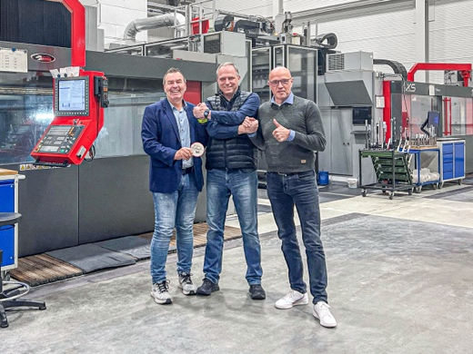
image001.jpg
Josef Wolpert (left) and Thilo Hofmann (right), representing the 500th proud VDWF member, Wolpert Modell- und Formenbau in Bretzfeld, alongside VDWF Managing Director Ralf Dürrwächter.
Image: VDWF

