2022 trophy goes to two "doers and makers" in science and industry

Carl Hanser Verlag, and VDWF Distinguished Profs. Dr. Thomas Seul and Kurt Gebert win the Dr. Richard Escales Prize 2022

The Dr. Richard Escales Prize was awarded for the ninth time on the first evening of the K trade show in Düsseldorf on October 19th. What made it special is that this is the first time the prize has been awarded in two fields of work: Prof. Dr. Thomas Seul was honored in the "Research and Development" category for his commitment and special achievements in communicating plastics technology expertise across different disciplines. Entrepreneur Kurt Gebert received the award in the "Industry" category for his commitment to promoting innovation in plastics technology, and collaboration across company and organizational boundaries. Every three years, Carl Hanser Verlag and the VDWF honor people in the plastics industry who have made outstanding contributions to the field of plastics technology through this award. The jury received around a dozen detailed nomination proposals this year.

The award winners

Prof. Dr. Thomas Seul has rendered outstanding services to the plastics industry as a professional and communicative mediator between the worlds of injection molding, moldmaking, and medical technology. His extraordinary expertise - starting with product development and the qualification of injection molds and processes - culminated in bioanalytics in investigations into the biocompatibility of plastics. In 2007, he established the Department of Applied Plastics Technology at the Schmalkalden University of Applied Sciences, which he permanently expanded in terms of both expertise and personnel. Together with colleagues, he initiated practical, in-service continuing education programs and distance learning courses. Numerous publications in professional journals and submitted patents are signs of his commitment to being a link between the various scientific disciplines. Together with his colleague Prof. Dr. Stefan Roth, the award winner has also compiled his accumulated experience and practical knowledge in the book "Kunststoffe in der Medizintechnik" (Hanser). As a speaker or participant in panel discussions, Seul enriches specialist meetings and conferences. The award winner also plays an important role as chairman within the framework of VDI-guideline work. Last but not least, he plays an important role as President of the VDWF and the Forschungsgemeinschaft Deutscher Werkzeug- und Formenbauer (FDWF - Research Association of German Moldmakers and Toolmakers), which was just newly founded in 2021. There are many more roles he fills, the jury said. As a thought leader, a motivator, a creative mind, and a toolmaker savant.

Kurt Gebert originally comes from a bakery and actually wanted to study mechanical engineering. But - fortunately - his brother was able to get him interested in plastics technology. Kurt Gebert "melts" for the design possibilities of this material and its seemingly never-ending different properties. According to the jury, this is one of the reasons the engineer was awarded this prize. He wrote the final thesis in his plastics engineering studies at the University of Applied Sciences in Würzburg on the subject of "rubber analysis" for Audi and then lived out his enthusiasm for soft materials at Mercedes. The award winner also thinks it is important to remember that success is also always a team effort – and that is why he is so happy to know everyone he does today. This network is certainly structured: For example, he is active on the board of the VDI Plastics Technology Division, on the research advisory board of the German Rubber Society (DKG), and in Forum Werkstoffe e.V. In addition, he can be found in many plastics associations in his Franconian homeland, but also nationally. He also moves in circles you can't just join, but have to be appointed to, such as being a "plastics knight" in the VDI strategy circle for plastics technology.

The trophy

In early 2019, Carl Hanser Verlag commissioned the Italian artist Lady Be to create a mosaic depicting the award's namesake. Dr. Richard Escales had founded the magazine "Kunststoffe" in 1910, which is now published by Carl Hanser Verlag. The special feature of the colored work (based on a black-and-white drawing over 100 years old) is that all the "mosaic tiles" that make up the portrait - some of them toy figures that are easily recognizable on closer inspection ¬ are plastic. The intention was to have the ordered 30 × 30 cm mural reproduced in the future as a new and unmistakable trophy using an additive manufacturing process. Antonius Köster spearheaded the plan, which presented numerous challenges - even during scanning due to the painted and extremely fissured mosaic surface. The replica data prepared by canto Ing. was finally printed on a J750 from Stratasys, which uses UV light to cure colored photopolymers to create the original colors. Transparent material was also processed in the addionally created base showing the award winners’ name. As a result, the white lettering appears to float in areas necessary for stability.

The Dr. Richard Escales Award

The Dr. Richard Escales Prize is a media prize awarded every three years for outstanding achievements in communicating technical plastics knowledge. Richard Escales, the award’s namesake, lived from 1863 to 1924. He was an application-oriented chemist and author of several important publications on chemical engineering. His creation of a word for the title of the journal he founded, Kunststoffe (“Plastics”), was groundbreaking and ultimately had a decisive influence on German usage.

The previous winners of the prize, which has been awarded by Carl Hanser Verlag since 1998, include Dr. Erwin Bürkle (1998), Prof. Dr. Tim Osswald (2001), Dr. Erwin Baur (2004), Prof. Dr. Christian Bonten (2007), Prof. Dr. Georg Steinbichler (2010), Prof. Dr. Erich Wintermantel (2013), Prof. Dr. Sonja Pongratz (2016) and Prof. Dr. Andreas Gebhardt (2019).

This year, the festive presentation of the Dr. Richard Escales Award was again jointly organized by Carl Hanser Verlag and the VDWF. "Kunststoffe" editor-in-chief Susanne Schröder and her colleague Florian Streifinger hosted the evening and welcomed over 100 guests from the plastics industry to the awards ceremony.

Captions

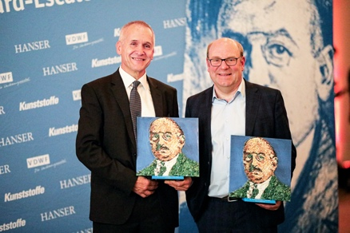

M42_7714.jpg
The honorees: Kurt Gebert (left) received the Dr. Richard Escales Award in the "Industry" category, Prof. Dr. Thomas Seul in the "Research and Development" category.
(Photo: VDWF)

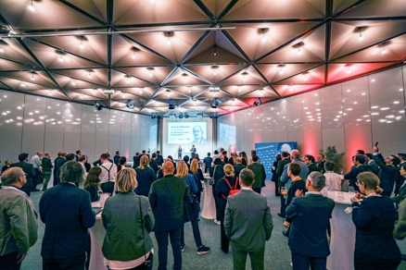

M41_9687.jpg
Over 100 guests accepted Carl Hanser Verlag and the VDWF’s invitation to Düsseldorf.
(Photo: VDWF)

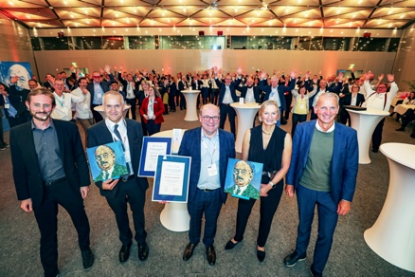

M41_9741.jpg
The award winners Kurt Gebert (2nd from left) and Prof. Dr. Thomas Seul (center) with the hosts from Carl Hanser Verlag: Susanne Schröder, Florian Streifinger (left) and Oliver Rohloff (right).
(Photo: VDWF)

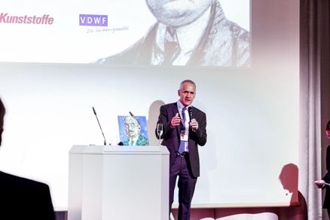

M42_7435.jpg
Entrepreneur Kurt Gebert received the Dr. Richard Escales Award in the "Industry" category for his commitment to promoting innovation in plastics technology and collaboration across company and organizational boundaries.
(Photo: VDWF)

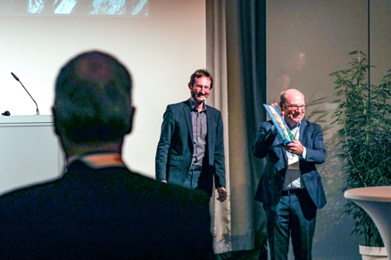

M42_7630.jpg
Prof. Dr. Thomas Seul was awarded the Dr. Richard Escales Prize in the "Research and Development" category for his commitment and special achievements in communicating plastics technology expertise across different disciplines.
(Photo: VDWF)

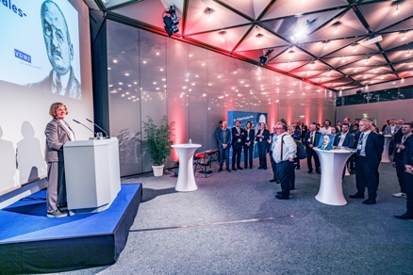

M41_9748.jpg
Sabine Escales, granddaughter of Dr. Richard Escales, addressed her words of thanks to the honorees and to the event's sponsors.
(Photo: VDWF)

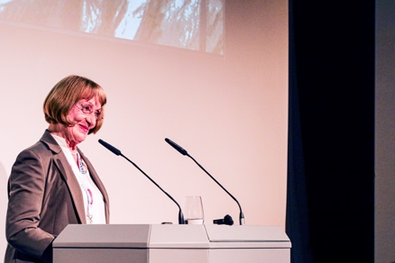

M42_7659.jpg
Sabine Escales, granddaughter of Dr. Richard Escales, addressed her words of thanks to the honorees and to the event's sponsors.
(Photo: VDWF)

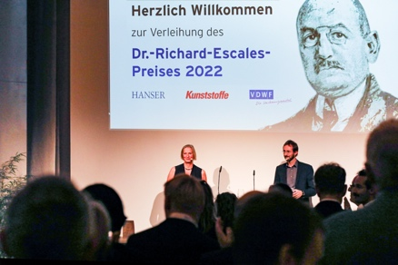

M42_7335.jpg
"Kunststoffe" Editor-in-Chief Susanne Schröder and her colleague Florian Streifinger hosted the evening and welcomed over 100 guests from the plastics industry to the awards ceremony in Düsseldorf.
(Photo: VDWF)

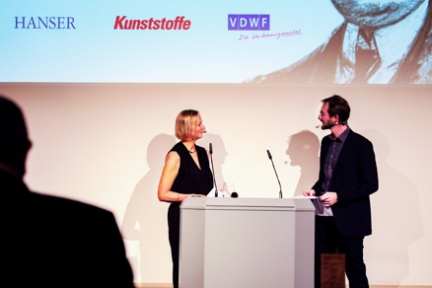

M42_7458.jpg
"Kunststoffe" editor-in-chief Susanne Schröder and her colleague Florian Streifinger hosted the evening and welcomed over 100 guests from the plastics industry to the awards ceremony in Düsseldorf.
(Photo: VDWF)

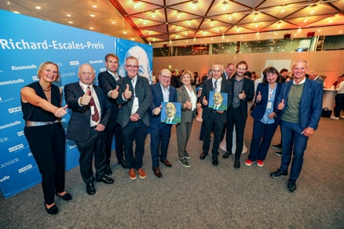

M41_9764.jpg
"Kunststoffe" editor-in-chief Susanne Schröder with previous award winners Dr. Erwin Baur (2004), Prof. Dr. Christian Bonten (2007), and Prof. Dr. Tim Osswald (2001), as well as with Prof. Dr. Thomas Seul, Sabine Escales (Dr. Richard Escales’ granddaughter), Kurt Gebert, "Kunststoffe" editor Florian Streifinger, Livia Masini-Zwick (Dr. Richard Escales’ great-granddaughter), and the Managing Director of Carl Hanser Verlag Oliver Rohloff (from left).
(Photo: VDWF)

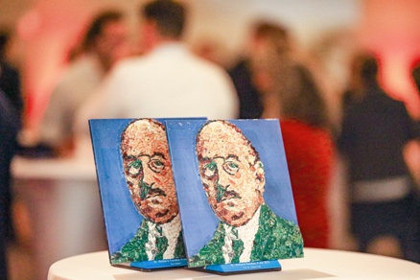

M42_7822.jpg
The trophies are a replica of the mosaic Italian artist Lady Be created of the award’s namesake: Dr. Richard Escales had founded the magazine "Kunststoffe" in 1910.
(Photo: VDWF)

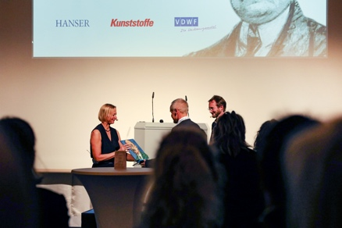

M42_7412.jpg
Entrepreneur Kurt Gebert received the Dr. Richard Escales Award in the "Industry" category for his commitment to promoting innovation in plastics technology and collaboration across company and organizational boundaries.
(Photo: VDWF)

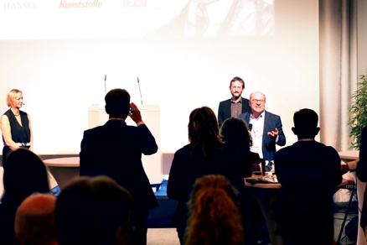

M42_7582.jpg
Prof. Dr. Thomas Seul was awarded the Dr. Richard Escales Prize in the category of "Research and Development" for his commitment to and special achievements in communicating plastics technology expertise across different disciplines.
(Photo: VDWF)

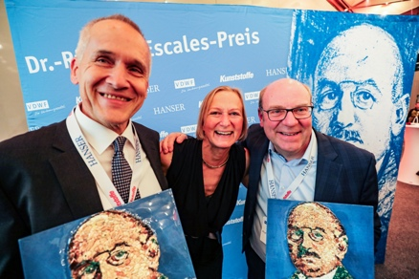

M41_9788.jpg
"Kunststoffe" editor-in-chief Susanne Schröder with the two award winners Kurt Gebert (left) and Prof. Dr. Thomas Seul.
(Photo: VDWF)

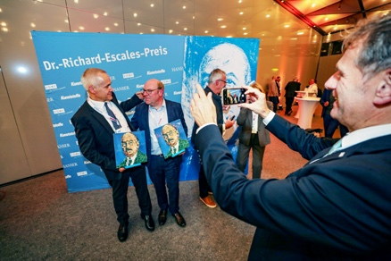

M41_9773.jpg
Prof. Dr. Christian Bonten, who was awarded the Dr. Richard Escales Prize in 2007, snaps a picture of the two current prize winners Kurt Gebert (left) and Prof. Dr. Thomas Seul.
(Photo: VDWF)

