2021 Tool and Mold Making Medal of Honor for Lothar Horn

The Tool and Mold Making Medal of Honor is an award that has been presented to deserving people in the industry at the Exhibitors Evening since the beginning of the Moulding Expo. It is given to pioneers and visionaries who have made groundbreaking predictions for the industry and are role models. The tradition was continued at this year's virtual trade fair evening on June 10th, during the VDWF's Late Shift "Mex-Special". The award winner this time is an entrepreneur who makes a lot of difference in the industry: Lothar Horn, Managing Director of Paul Horn GmbH in Tübingen.
The Tool and Mold Making Medal of Honor was created to pay tribute to the achievements of deserving people in the tool, model, and mold making industry. They are people who have made and continue to make a difference in this field. The award is explicitly not a lifetime achievement award. The jury hopes that the award winners will continue to set an example for all those who are active in this industry or who want to become active. In particular, award winners are also role models for young people and beacons beyond the industry.
When selecting candidates, Prof. Wolfgang Boos, Managing Director of the WBA Werkzeugbauakademie Aachen, Ralf Dürrwächter, Managing Director of the VDWF, Richard Pergler, owner of Pergler Media, and Alfred Graf Zedtwitz, Press Spokesman of the Precision Tools Association of the VDMA, always proceed with the greatest care. There are, after all, many people deserving of such an award in the industry. And so, the jury meetings sometimes drag on. But this year was different: in his laudatory speech, Richard Pergler revealed, "One name was mentioned – and the jury members immediately broke into broad smiles”. That had never happened before.
Entrepreneurial personality par excellence
This year's award winner is Lothar Horn, Managing Director of Paul Horn GmbH in Tübingen. He is an entrepreneurial personality par excellence. Pergler stated: "Even though he directs and manages a really big company in the industry, he has remained true to himself over all these years, accessible to all, approachable. A human being." He’s a person with charisma. Lothar Horn leads his employees as a personal role model and, above all, has left a lasting mark on his company in his very own style. This includes not only the atmosphere and the people in the company, but also his way of dealing with users, customers, and suppliers. Rarely is there as much laughter as in his presence. In short: Lothar Horn creates space for the people around him so that they can develop.
The 64-year-old carries the name of his company, and with it the industry, out into the world. At Hartmetall-Werkzeugfabrik Paul Horn GmbH, he has built up an internal toolmaking department for special processes that is hard to find anywhere else. He is a constant pioneer in this field. Lothar Horn was chairman of the VDMA Precision Tools Association for many years and, in addition to his entrepreneurial activities, also acts as a representative and ambassador for the industry worldwide. His impact also extends beyond his role as a businessman at his company: social commitment is a serious and personal concern for him in many areas and projects.
The industry congratulates!
On behalf of Lothar Horn, who was unable to take part in the online award ceremony at short notice, his son Markus Horn accepted the medal of honor – which, incidentally, was not produced with just any tool. After the jury meeting, the WBA Aachener Werkzeugbauakademie (which designed and manufactured the trophy this time) embarked on a stealthy mission to procure Horn tools from Tübingen since the award should be a surprise. According to the jury, the tools proved to be outstanding in the production of the medal. The approximately 130 guests at the VDWF Late Shift applauded, as did the jury members and guests of honor who were also present.
The next presentation of the Tool and Mold Making Medal of Honor will take place in 2023 – hopefully again at the Moulding Expo, live and in front of a "real" audience.

Captions
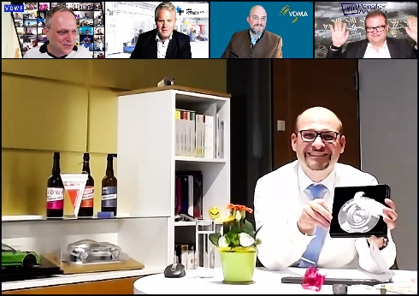
screenshot_2021_06_10_21_24_30.jpg
Markus Horn accepted the Tool and Mold Making Medal of Honor on behalf of his father Lothar Horn during the VDWF Late Shift "Mex Special". Jury members (from left) Ralf Dürrwächter (Managing Director of the VDWF), Prof. Wolfgang Boos (Managing Director of the WBA Werkzeugbauakademie Aachen), Alfred Graf Zedtwitz (Press Spokesman of the Precision Tools Association of the VDMA), and Richard Pergler (owner of Pergler Media) congratulated him online.
Photo: VDWF

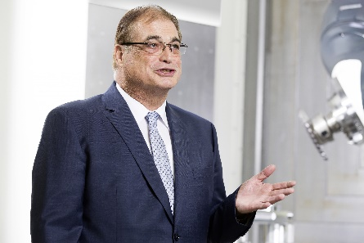
lothar_horn.jpg
Distinguished with the 2021 Tool and Mold Making Medal of Honor: Lothar Horn, Managing Director of Hartmetall-Werkzeugfabrik Paul Horn GmbH in Tübingen.
Photo: Paul Horn

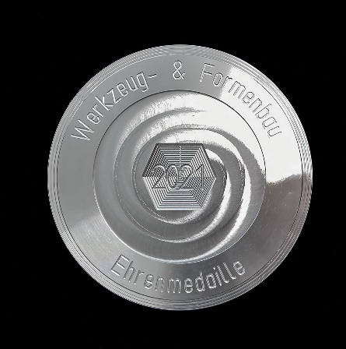
medal_of_honour.jpg
The 2021 Tool and Mold Making Medal of Honor was designed at the WBA Aachen Toolmaking Academy and made exclusively using Horn tools.
Photo: WBA Werkzeugbauakademie Aachen

High-resolution images can be found in the press section of the
VDWF website (www.vdwf.de/service/presse-vdwf).

