VDWF presents new guideline:
Working group develops a color table for CAD-supported transmission of tolerances in tool and mold making

Towards the end of last year, Dirk Falke, chairman of the «Color Table Working Group» and owner of the Falke engineering office, presented the guideline for CAD-supported transmission of tolerances drawn up by the committee. The new framework is intended to facilitate cooperation between companies and help avoid mistakes. For Dirk Falke, this is «association work done by the book». Through its working groups, the VDWF offers a structure for exchanging experiences and facilitating the industry-internal coordination needed for standardizing processes. VDWF President Prof. Thomas Seul also emphasized the importance of such results from the association's working groups when he presented the guideline, saying: «It is small steps like this one that makes digitization workable in our industry.»

Why was the guideline necessary? Toolmakers color code surfaces on CAD models to denote the required manufacturing accuracy of the design. This allows for the streamlining of one-off production processes. However, the fact that many companies have created their own color tables and there are therefore many different systems in use has limited the universal applicability of this sensible approach in recent years. As a result, errors were repeatedly introduced into daily production, when, for example, tool and mold manufacturers outsourced individual subtasks such as milling, drilling, or eroding work to external service providers. «Given that deadline and cost pressures are expected to rise, the need for networked work is also increasing» Dirk Falke explains. «That is where the color table developed by the VDWF can help prevent transmission errors», he concluded.

To this end, the VDWF initiated the «Color Table Working Group» in the Spring of 2019. Working together, a group of industry experts developed the guideline to standardize color coded CAD-supported transmission of tolerances in tool and mold making. Following the initial publication, there is now a review period of six months in order to assure transparency. During this time, suggestions for improvement and specification requests can be submitted to the VDWF. Relevant contributions will be incorporated into a revised version to be published in April 2021.

On behalf of the VDWF, Dirk Falke thanked all the experts who volunteered to create the guideline. The VDWF guideline «color table» (ISBN 978-3-00-065278-3) can be obtained from the association's office. It is available in both German and English.

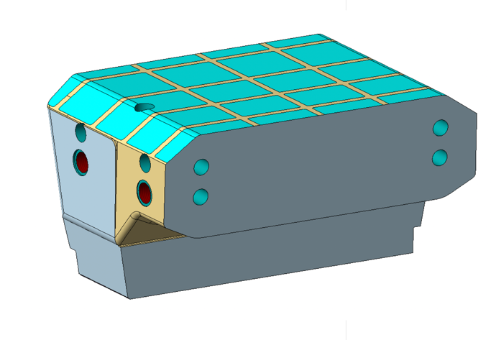
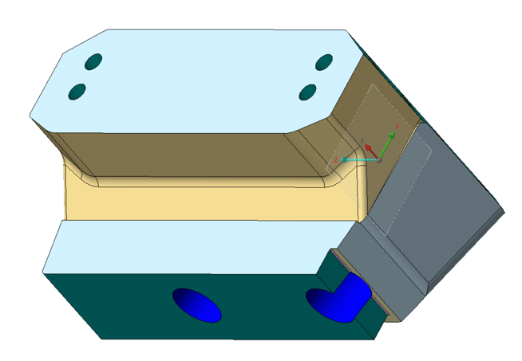
An example of a colored contour-forming
component of an injection molding tool

