A special kind of network:
30 years of VDWF

On November 5, 1992, 18 entrepreneurs from the tool and mold making industry met in a hotel in Bad Überkingen to pool their potential and represent it to the industry: And so, the VDWF was born. That small group has now grown into a network of around 480 members. The VDWF organizes a large number of seminars and events, is a co-initiator of the Molding Expo, has launched its own courses, founded a research community, and enters into dialogue with politicians in order to bring the interests of the industry to a broad public.

1996 saw the first delegation trip (to the USA); 2001 the first issue of the association magazine; regular networking events have taken place since 2005; 2010 saw a separate VDWF guideline for CE marking of tools. “What happened in the first twenty years were milestones for the VDWF as we know it today,” says the VDWF board. But a lot of new things have developed – especially in the last few years. The original idea has long since grown into a lively network through which companies can form strategic partnerships to jointly manage orders and capitalize on synergies.

VDWF President Prof. Thomas Seul explains that the VDWF also maintains interfaces with other industry associations and is above all a “voice” for the many smaller members who, through the association, can make themselves heard in the corporate groups, to clients, and in markets where they could not if they were alone. “It’s our job to pool the strengths and knowledge of our companies in order to attain the German speaking region’s leading position in international tool and mold making.” For Seul, this was true thirty years ago – and it still is now more than ever. The VDWF therefore offers competent advice and practical support on topics such as training and further education, marketing, management, and expert knowledge. The association is also involved on behalf of its members in higher-level issues, such as the DIN standards committee or the CE conformity of tools and molds. Education, technological excellence, visibility, and a culture of meeting are the four pillars of the association’s work, through which the VDWF would like to help to make its members, and the entire industry in the German-speaking region, fit for the future.

Through training and degrees with the VDWF

In 2011, the part-time further training course “Project Manager for Tool and Mold Making” was created in cooperation with the Schmalkalden University of Applied Sciences. The course is aimed specifically at up-and-coming specialists and managers in the industry. Seul, who also holds the office of Vice President for Research and Transfer at Schmalkalden University, explains that: “The focus of the teaching is aligned with the needs of the industry. It is also important to us that further education is available to anyone who is interested – which is why this program can also be completed as a distance-based learning course and is therefore easily compatible with professional and private commitments.” The course was a great success, and a series of additional courses were introduced: The master’s course “Applied Plastics Technology” in 2012, the master’s course “Mechanical Engineering and Management” in 2014, the master’s courses “Computer Science and IT Management” and “Electrical Engineering and Management” in 2016, and finally the certificate course “Application Engineer for Additive Processes/Rapid Technologies” in 2017. In the past three years, the Schmalkalden University of Applied Sciences has been named “Top Distance-Based Learning Provider” by the independent evaluation portal FernstudienCheck. Seul notes that, “As an association and as a university, we were of course very pleased about this positive response.”

At that same time in 2012, a trainee initiative was started. In addition to their in-company training, trainees can acquire special knowledge in tool and mold making in two-week block courses. Through both the training initiative and courses, the VDWF is laying the foundation to ensure the industry’s favorable future by introducing young people to this complex field of work in the best possible way.

FDWF: Bridge between industry and research

In addition to training, the VDWF is also involved in science: The Research Community of German Tool and Mold Makers (FDWF) was founded in 2021 to advance pre-competitive research and thus strengthen the industry, which is primarily characterized by SMEs. The inclusion of the FDWF as the 100th member of the German Federation of Industrial Research Associations (AiF) in the same year. In his function as chairman of the FDWF, Seul explains that “With the research community, we want to build a bridge between science and industry – that’s why we take feedback from companies on which developments would be useful in practice and define the research priorities accordingly.”

Constructive dialogue with politicians

Targeted research – a way to advance tool and mold making in German-speaking countries. But problems such as increasing price pressure in international competition, delivery bottlenecks, uncertainty in the automotive industry, or changing markets remain. To strengthen the industry’s scope for action, the VDWF started a conversation with politicians: In 2017, Baden-Württemberg’s Prime Minister Winfried Kretschmann emphasized the key function of the industry in his laudation of the association’s 25th anniversary. So did Gerald Ullrich – a member of the Bundestag – who, as a production manager for plastics technology, knew the importance of toolmakers in industrial processes all too well. Then, in 2021, the VDWF initiated several round tables: In Haigerloch, there was a meeting with Thomas Bareiß, a member of the Bundestag, in his function as the Federal Government Commissioner for SMEs. In Baienfurt, there was meeting with the Baden-Württemberg Minister of Economic Affairs, Dr. Nicole Hoffmeister-Kraut. According to VDWF Managing Director Ralf Dürrwächter, “The discussion was definitely constructive for both sides. After all, it is in all our interests for tool and mold making to a key industry in Germany as a business location.” Further meetings are already being planned.

The VDWF as a meeting place

Even outside of politics, the dialogue between association members was and is the focus of the association’s work: the core and foundation of the VDWF is its active association network, which can be found in the practical forums, specialist events, training courses, seminars, joint stands at trade fairs, delegation and study trips, as well as informal events such as ski weekends and barbecues. Due to the pandemic beginning in 2020, many face-to-face events had to be canceled and postponed – but in no way did that mean the end of communal get-togethers: The VDWF established uncomplicated online formats such as the “11-Uhr-Loch” or the “Spätschicht”, which were immediately well received and used by the membership. These opportunities for inter-regional networking and range extension from one’s desk will continue to be an integral part of association life in the future. “We want to communicate with our members too, but primarily members should find each other through the association and communicate with each other,” explains Dürrwächter. The VDWF wants to be one thing above all: an active and attractive meeting place that people are happy to join.

A special kind of network – with a befitting response

In 2018, the VDWF won second place in the German Society for Association Management (DGVM) competition in the “Association of the Year” category. The association magazine “VDWF im Dialog” won the mediaV award in 2019 for “Best Association Magazine”. And in 2021, Ralf Dürrwächter received the mediaV award for “Association Communicator of the Year”. 30 years of VDWF therefore also means 30 years of successful interchange – internally and externally.

Captions

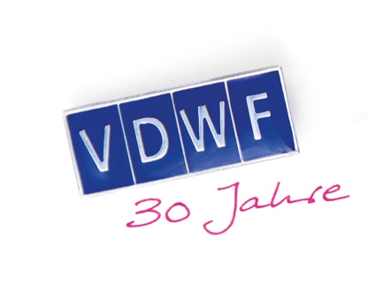
30_jahre_vdwf_logo.jpg
Image: VDWF

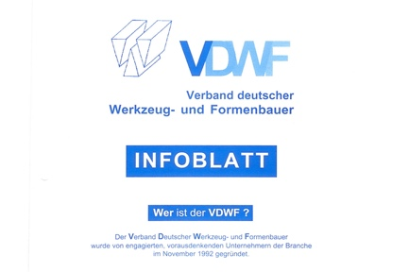
vdwf_infoblatt.jpg
Image: VDWF

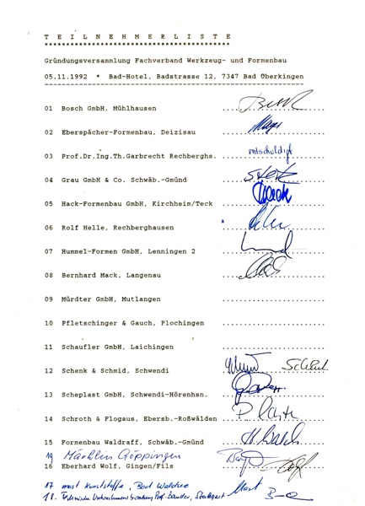
vdwf_gruendungsversammlung_teilnehmer.jpg

Birth of the VDWF: 18 small and medium-sized entrepreneurs met on November 5th, 1992 in the Bad Hotel in Bad Überkingen. Their goal was as follows: to found an association that will stand up for the interests of everyone in the industry with a strong voice, bundle the strengths and potential of the many small and medium-sized companies, and represent them to the industry.
Image: VDWF

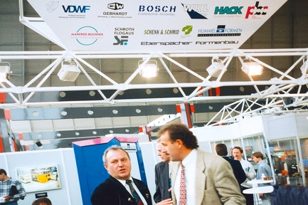
formtek.jpg
Formtek, VDWF’s attempt at its own trade fair: In 1993, the association organized its own trade fair together with the trade fair company Paul Schall in Sinsheim. Ten association members came together as exhibitors at “Formtek”. Lectures and discussions were organized to run parallel to the exhibition. The VDWF subsequently itself using a joint stand concept at important industry trade fairs such as Fakuma, Euromold, WFB, Blechexpo, Euroguss, Medtec, or the Molding Expo.
Image: VDWF

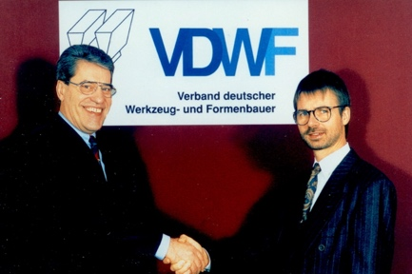
geschaeftsfuehrerwechsel.jpg
Handshake in 1994: Then VDWF President Prof. Thomas Garbrecht (r.) welcomes Dieter Döttling – the management consultant from Uhingen who was the managing director of the association between was 1994 and 2000.
Image: VDWF

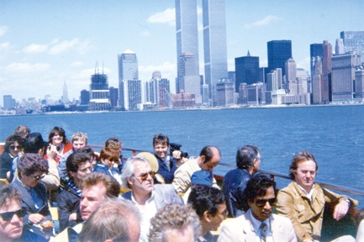
delegationsreise_usa.jpg
The first VDWF delegation trip was to the USA in 1996 in which around 20 participants went to see automation solutions on-site.
Image: VDWF

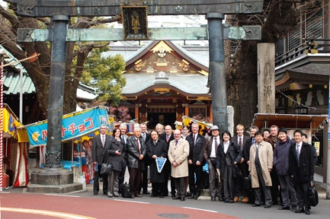
delegationsreise_japan.jpg
During their one-week study trip, the VDWF travel group was able to experience the philosophy with which Japan, as a high-tech country, faces global challenges in terms of mechanical engineering, production technologies, and personnel management.
Image: VDWF

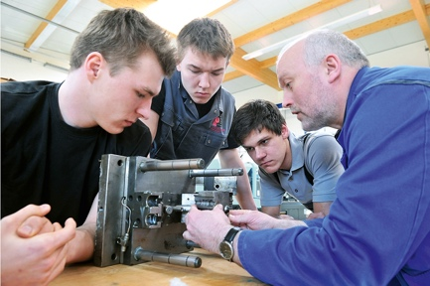
azubi_initiative.jpg
The VDWF training initiative has been qualifying the next generation of tool and mold makers since 2012: In addition to in-company training and vocational school, trainees can receive special knowledge during two-week block seminars at the Bildungs-Center Südthüringen (BCS) in Zella-Mehlis.

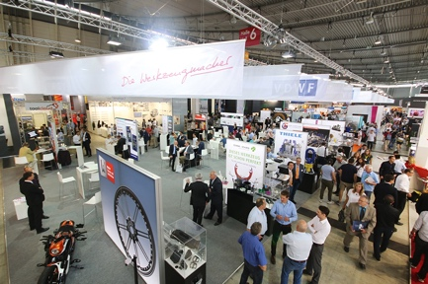
moulding_expo.jpg
One of the most successful trade fair launches: The Moulding Expo 2015 with well over 600 exhibitors in sold-out Stuttgart exhibition halls. And right in the middle of it all, the VDWF was a conceptual and professional sponsor. Its joint stand had never existed before. At around 700 m², the stand was then the largest in the history of Messe Stuttgart. Apart from the new stand concept, the VDWF was present with 82 other exhibitors.
Image: VDWF

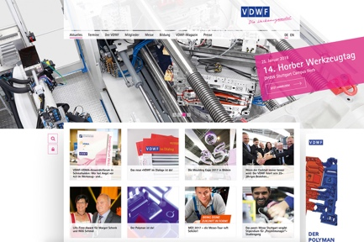
website.jpg
Relaunch of the VDWF website in 2015: Since then, the association’s website has not only had a new look, but has also been in two languages and had new functions such as online booking and order management.

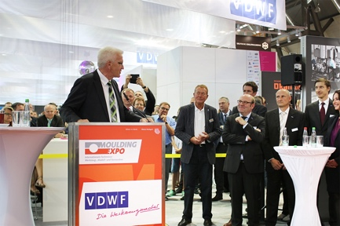
25_jahre_vdwf.jpg
The Prime Minister of Baden-Württemberg, Winfried Kretschmann, gave the keynote at the VDWF’s 25th anniversary in 2017. He emphasized the key role played by the tool and mold making profession in industrial production.
Image: VDWF

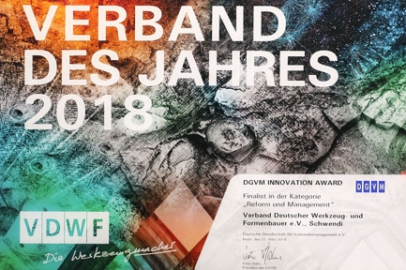
verband_des_jahres.jpg
2nd place as “Association of the Year” in Berlin: Only a micrometer was missing to the top spot on the podium – and that’s why President Prof. Thomas Seul and Managing Director Ralf Dürrwächter smiled with pride and satisfaction when they met at the evening’s festivities for the 16th German Associations Congress of the German Society for Association Management (DGVM) in Berlin in 2018. They received the second-place award in the “Association of the Year 2018” competition.
Image: VDWF

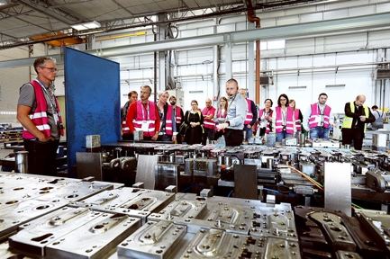
voll_wild.jpg
VDWF Managing Director Meeting “Wild Life” on the road: four countries in four days. In autumn of 2018, the VDWF and its Managing Director Meeting visited toolmakers in Italy, Slovenia, Austria, and Germany. With around 40 participants, the association toured a total of eleven companies.
Image: VDWF

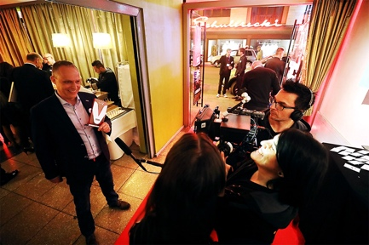
mediav_award.jpg
“VDWF im Dialog” wins the 2019 mediaV-Award. The association magazine was awarded the 2019 mediaV-Award in the category “Best Association Magazine” with the jury verdict of “Young, high-quality, and entertaining”. Among other things, the magazine was also praised for its comprehensive communication concept because it builds bridges to the association’s online presence. The lively, modern, and in parts “impetuous layout”, as well as the many pictures provide variety. The covers are aesthetic and always catch the eye. The jury members unanimously emphasized the “high quality of the magazine”, which thinks outside the box, but above all makes the association and its achievements visible.
Image: VDWF

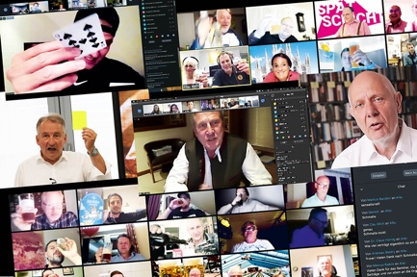
spaetschicht.jpg
The “Late Shift” is the second online platform the association has created with which the industry has come together in 2020. In addition to lectures, company presentations, and international greetings from guests, the informal get-together offers a lively exchange.
Image: VDWF

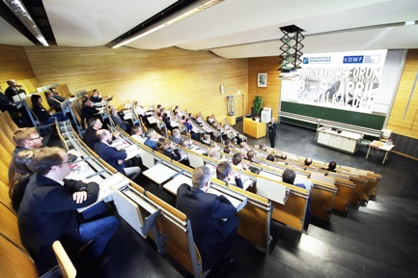
thomas_seul_alumnitreffen.jpg
Six VDWF courses in Schmalkalden: Prof. Dr. Thomas Seul (Vice President of the Schmalkalden University of Applied Sciences and President of the VDWF) welcomes the participants of the alumni meeting. The two-day event last took place in 2016 as part of the Innovation Forum for Plastics Technology and Toolmaking at the Schmalkalden University of Applied Sciences.
Image: VDWF

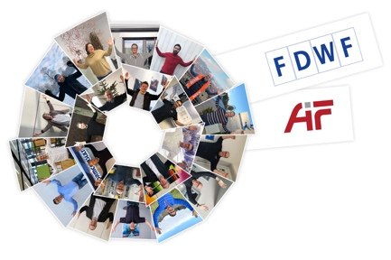
fdwf_aif.jpg
Research Association for Tool and Mold Making (FDWF)
Around two thirds of the ca. 3,800 tool and mold making companies in Germany employ fewer than 50 people – and most do not have their own research or development departments. Therefore, on the initiative of the VDWF, the FDWF was launched in spring of 2021. The foundation of this research community should promote tool and mold making in German speaking countries though the targeted transfer of scientific knowledge to companies. It should also support the industry’s internationally leading positions.
Image: VDWF

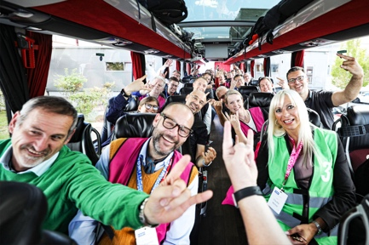
voll_wild_on_tour_a_i_ch_d.jpg
In mid-September, “Wild Life” was on a four-day tour: In a luxurious VIP coach, the four-country trip first went to Austria and then on to northern Italy. Further stops in Switzerland were followed by the transfer to the Black Forest. Highlights between the company visits during the VDWF tour were the highly communicative bus rides with two moderated discussion rounds and the evening events in Milan, on Lake Maggiore and in Schwenningen, each of which the hosts had organized for the 35-strong travel group.
Image: VDWF

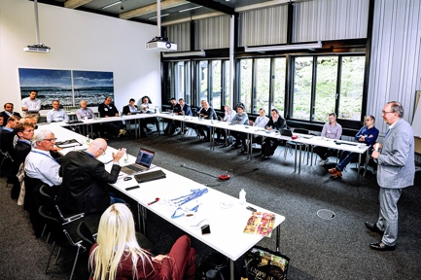
vdwf_praxisforum_additive_fertigung.jpg
What began as a VDWF working group with the aim of gathering experience with additive manufacturing processes and exchanging views on this with industry players, kicked off the VDWF Practical Forum “Additive Manufacturing” in Ditzingen. Following the forums on toolmaking and plastics technology, this is the third practical forum initiated by the VDWF and offers participants the latest impetus from research, coupled with a fruitful exchange of practical experience.
Image: VDWF

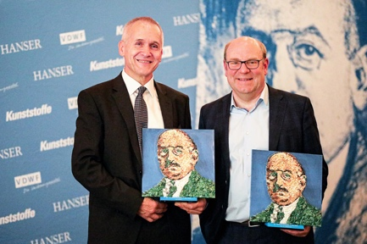
dr_richard_escales_preis_2022.jpg
On the first evening of the K trade show in Düsseldorf, the Dr. Richard Escales Award was presented for the ninth time. VDWF President Prof. Dr. Thomas Seul received the prize in the “Research and Development” category for his commitment and special achievements in communicating plastics technology expertise between different disciplines. In the “Industry” category, entrepreneur Kurt Gebert was honored for his commitment to promoting innovations in the field of plastics technology.
Image: VDWF

